A | B | S | q
0 | 0 | 0 | 0
0 | 0 | 1 | 0
0 | 1 | 0 | 0
0 | 1 | 1 | 1
1 | 0 | 0 | 1
1 | 0 | 1 | 0
1 | 1 | 0 | 1
1 | 1 | 1 | 1

AB \ S | 0 | 1
00 | 0 | 0
01 | 0 | 1
11 | 1 | 1
10 | 1 | 0
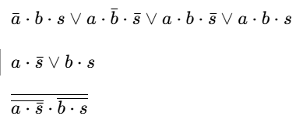

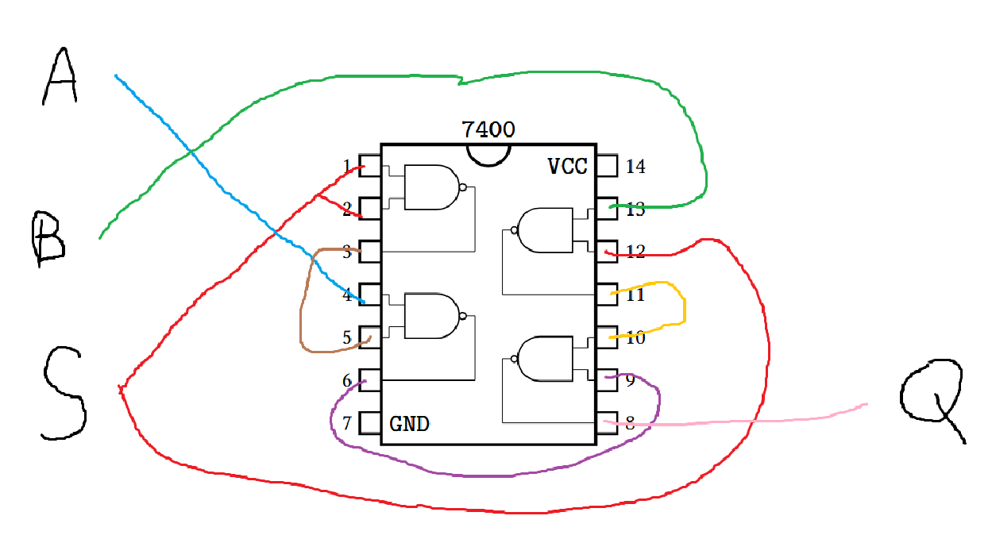

Ph | C | p | C et p | s
0 | 0 | 0 | 0 | 0
0 | 0 | 1 | 0 | 0
0 | 1 | 0 | 0 | 0
0 | 1 | 1 | 1 | 0
1 | 0 | 0 | 0 | 0
1 | 0 | 1 | 0 | 1
1 | 1 | 0 | 0 | 0
1 | 1 | 1 | 1 | 0



